|  |  |
| --- | --- |
| Logo UNIMAS | **UNIVERSITI MALAYSIA SARAWAK**  **Faculty of Computer Science and Information Technology** |

**Assignment/Report Cover Sheet**

|  |  |  |
| --- | --- | --- |
| Student Name | Student Id Number | Signature |
| 1. Mahmoud Kassab 2. AFIQ BIN AYUBEIDRIS 3. NORAZZIERA BINTI MOHD HELIK 4. NUR SYAFITRIYANA BINTI SABAS 5. THEVARASAN A/L MANIKAVASAN | 68848  65315  68641  68680  68754 | **Mahmoud**  **Afiq**  **Norazziera**  **Nur syafitriyana**  **Thevarasan** |

|  |  |
| --- | --- |
| Subject Code: TMT3123 | Subject Name: COMPUTER GAMES DESIGN AND DEVELOPMENT |

|  |  |
| --- | --- |
| Assignment Title: | ASSIGNMENT 1 |

|  |  |
| --- | --- |
| Due Date: 5.00 pm, 11 December 2020 | Date Submitted: 5.00 pm, 11 December 2020 |

This cover sheet must be completed, signed and firmly attached to the front of the submission. All work must be submitted by the due date. If an extension of work is granted, an assignment extension acknowledgement slip must be signed by the lecturer/tutor and attached to assignment. Please note that is your responsibility to retain copies of your assignment.

|  |
| --- |
| ***Plagiarism and Collusion are methods of cheating that falls under Peraturan Akademik Universiti Malaysia Sarawak para 11: Etika Akademik***  **Plagiarism**  Plagiarism is the presentation of work which has been copied in whole or in part from another person’s work, or from any other source such as the internet, published books or periodicals without due acknowledgement given in the text.  **Collusion**  Collusion is the presentation of work that is the result in whole or in part of unauthorized collaboration with another person or persons.  Where there are reasonable grounds for believing that cheating has occurred, the only action that may be taken when plagiarism or collusion is detected is for the staff member not to mark the item of work and to report or refer the matter to the Dean. This may result in work being disallowed and given a fail grade or if the circumstances warrant, the matter may be referred to a Committee of inquiry for investigation. Such investigation may result in the matter being referred to the University Discipline Committee, **which** has the power to exclude a student. |

|  |
| --- |
| **Upon placing signature above, I certify that I have not plagiarized the work of others or participated in unauthorized collusion when preparing this assignment.**  **I also certify that I have taken proper case in safeguarding my work and have made all reasonable efforts to ensure that may work not be able to be copied.** |

|  |
| --- |
| **MARK :** |

**Table of contents**

|  |  |
| --- | --- |
|  | Page number |
| 1. Game’s Title & cover ------------------------------------------------------------------------------------- 4 | |
| 1. Design history ----------------------------------------------------------------------------------------------- 5    1. Version 1.01 ------------------------------------------------------------------------------------------- 5 | |
| 1. Game overview --------------------------------------------------------------------------------------------- 6    1. Introduction -------------------------------------------------------------------------------------------- 6    2. Philosophy --------------------------------------------------------------------------------------------- 7    3. Common Questions ---------------------------------------------------------------------------------- 7 | |
| 1. Feature set ---------------------------------------------------------------------------------------------------- 9    1. General Features -------------------------------------------------------------------------------------- 9    2. Gameplay ----------------------------------------------------------------------------------------------- 9 | |
| 1. The game world -------------------------------------------------------------------------------------------- 10    1. Overview ----------------------------------------------------------------------------------------------- 10    2. Physical-world dimension ------------------------------------------------------------------------- 10    3. Temporal dimension -------------------------------------------------------------------------------- 11    4. Environmental dimension -------------------------------------------------------------------------- 11    5. Emotional Dimension ------------------------------------------------------------------------------- 11 | |
| 1. The world layout ------------------------------------------------------------------------------------------- 13    1. Overview ----------------------------------------------------------------------------------------------- 13    2. Level selection ---------------------------------------------------------------------------------------- 13    3. Level layout ------------------------------------------------------------------------------------------- 13 | |
| 1. Game characters -------------------------------------------------------------------------------------------- 15    1. Overview ----------------------------------------------------------------------------------------------- 15    2. Characters ---------------------------------------------------------------------------------------------- 15    3. Enemies and Monsters ------------------------------------------------------------------------------ 15 | |
| 1. User Interface ----------------------------------------------------------------------------------------------- 16    1. Overview ----------------------------------------------------------------------------------------------- 16    2. Buttons ------------------------------------------------------------------------------------------------- 16    3. Screens ------------------------------------------------------------------------------------------------- 16 | |
| 1. Weapons ----------------------------------------------------------------------------------------------------- 18    1. Overview ----------------------------------------------------------------------------------------------- 18    2. Main character weapons ---------------------------------------------------------------------------- 18    3. Secondary characters weapons ------------------------------------------------------------------- 18 | |

|  |
| --- |
| 1. Musical scores and sound effects --------------------------------------------------------------------- 19    1. Overview ------------------------------------------------------------------------------------------------ 19    2. Background music ------------------------------------------------------------------------------------ 19    3. Sound effects ------------------------------------------------------------------------------------------- 19 |
| 1. Single-player game ---------------------------------------------------------------------------------------- 20    1. Overview ------------------------------------------------------------------------------------------------ 20    2. Story ----------------------------------------------------------------------------------------------------- 20    3. Hours of Gameplay ----------------------------------------------------------------------------------- 20    4. Victory Conditions ----------------------------------------------------------------------------------- 20 |
| 1. Character rendering --------------------------------------------------------------------------------------- 21    1. Overview ------------------------------------------------------------------------------------------------ 21    2. Character design -------------------------------------------------------------------------------------- 21    3. Rendering ----------------------------------------------------------------------------------------------- 21 |
| 1. Miscellaneous ----------------------------------------------------------------------------------------------- 23    1. Credits --------------------------------------------------------------------------------------------------- 23    2. Bonus Materials --------------------------------------------------------------------------------------- 23 |
| 1. Appendices -------------------------------------------------------------------------------------------------- 24    1. Levels appendix --------------------------------------------------------------------------------------- 24    2. Objects Appendix ------------------------------------------------------------------------------------- 24    3. Characters and weapons appendix ---------------------------------------------------------------- 24    4. Rating Appendix -------------------------------------------------------------------------------------- 24    5. Tools Appendix --------------------------------------------------------------------------------------- 24 |
| 1. References --------------------------------------------------------------------------------------------------- 27 |

Goldenberry (GB)

**Design Document for:**

**DEFEAT CORONI**

**Shoot coroni and save the world**

“back to the streets!” ™

All work Copyright ©2020 by Goldenberry (GB)

Written by Mahmoud Kasab, Afiq Bin Ayubeidris, Norazziera Binti Mohd Helik, Nur Syafitriyana Binti Sabas and Thevarasan A/L Manikavasan

Version # 1.02

Sunday, January 10, 2021

1. **Design history**

In this section, our team will briefly describe the changes in the game design.

In order to achieve fast performance on low specs devices like mobile phones, our team updated the game design to be less detailed, in which the player will only move horizontally and not vertically by changing the usual player movement to only move forward in the scene.

* 1. **Version 1.01**

The changes that were added or updated in this version are as follows:

* Change level design for the game
* Change player movement from horizontally and vertically to only horizontally
  1. **Version 1.005**

The changes that were added or updated in this version are as follows:

* Change level design for the game
* Change player movement added vertical movement
* Change camera movement behavior to allow player to go back

1. **Game overview**
   1. **Introduction**

Defeat Coroni is a simple 2D adventure game that runs on Android devices and a personal computer or laptop. It combines the concept of platformer games that consist of exploration, fighting, and go through adventures. This game is suitable for all players around the world of all ages. The player will travel through the city all the way to her final destination. On the way, there will be a checkpoint in the middle of the city which is guarded by the police, this will act as a save point in the game.

The player will only be given 5 times protection as 5 lives against the coronavirus before she loses the game. In this game, we will provide three stars level difficulties where the one-star level or the easiest level will take place in the hospital, the two-star level or medium-level at the supermarket, and the three-star level or the hardest level at the cafe. Furthermore, it uses colorful graphics and a cute theme song to give a bright and adventurous playing mood. To conclude, the objectives of Defeat Coroni are to create and raise awareness on how dangerous the Coronavirus disease (COVID-19) pandemic to the public and to appreciate the help of our front-line officers.

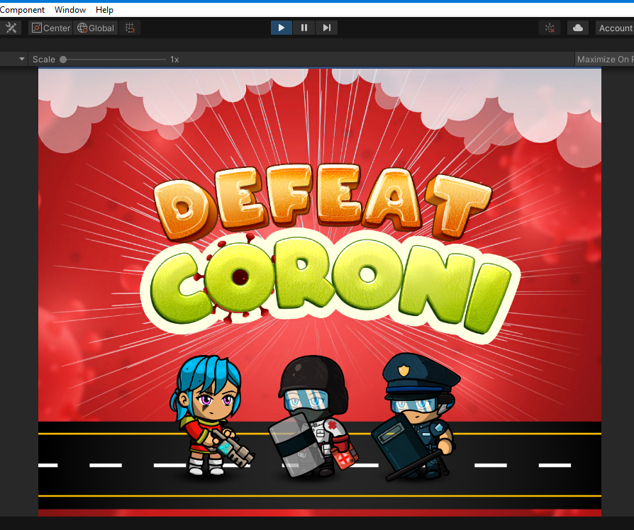

* 1. **Philosophy**

*Philosophical point #1*

The concept of this game is slightly similar to the great famous game of “Super Mario” except this one is created with a custom feel and look to give information and create awareness about the dangerousness of Coronavirus disease (COVID-19) that happened around the world these days.

*Philosophical point #2*

This game runs on both Android devices and personal computer or laptop to give an option to players which some prefer playing games using small devices and some prefer using their personal computer. As this game is developed using Unity, it can run on multiple systems but our team mainly focusing on Android as its users are increasing rapidly in the past few years.

*Philosophical point #3*

The overall design of the game is a 2D game. The 2D game is combined with a cheerful and colorful theme concept to capture the player’s attention and to create a happy playing mood during the gameplay.

* 1. **Common Questions**

*What is the “defeat coroni” game?*

This game is about a human who is facing the crisis attack of COVID-19. From the game itself, we are trying to portray the danger of making contact and become infected with COVID-19 by creating a game to defeat coronavirus. In the game itself, the coronavirus or the enemy will try to touch the player and will shoot things at the player. The player’s main task is to avoid the coronavirus at all costs. When the player killed the corona, a coin as a token will drop down for the player to collect. Fundamentally, this game is trying to create and raise awareness of how dangerous Coronavirus disease (COVID-19) to the public and the need to eliminate it from this world and also to promote the use of face masks and the effort of the front line officers.

*Why creates this game?*

The increase in people who love playing games leads to the creation of this game. Not only that, the increase in the accessibility and availability of smartphones, tablets, and laptops give a potential for more users to play this game and use it as a platform to create and raise awareness on how dangerous the Coronavirus disease (COVID-19) pandemic to the public.

*Where does the game take place?*

The game takes place in a usual city, but with focusing on three different places defined as levels of difficulty where the one-star level or the easiest level will take place at the hospital, the two-star level or medium-level at the supermarket, and the three-star level or the hardest level at the cafe.

*What do I control?*

In terms of player movement, the player will move forward and backward horizontally and vertically in the scene and moving the camera back and forward.

Another control is the shooting in which the player can shoot the corona enemy with the weapon which is a laser gun.

*How many characters do I control?*

There are three main characters in the game, the policeman, the medic, and the hero, however, The player will only control one character the hero which is the main character of the game. For better performance the medic and police are static.

*What is the main focus?*

The main focus of the gameplay is to defeat the corona by destroying it with the provided weapons until you arrived at your destination without being affected by it.

*What’s different?*

It is not like the other games in which the game is being played by other players for excitement only, but it also acts as a medium to create awareness for something that happening around the world these days and to help in teaching the player the benefits of using face masks and appreciate the front line officers.

1. **Feature set**
   1. **General Features**

2D Graphics

RGB Color

8 Bit Color

* 1. **Gameplay**

This game has 4 levels to be complete. Each level is with different difficulties represented by stars which the easiest one is one star, the medium is two stars, the hard is the 3-star level this makes it more challenging for the player as he advances in the game.

The player can only move forward, backward, horizontally on the road and jump vertically.

Every time the player kills the enemy, a reward in a form of a coin will be dropped so she can collect it in her way.

The Player has only four lives to spare which are 5 hits by the enemy or the enemy weapon’s, she also has extra protection, she will get from the face mask she will acquire at the checkpoint at the roadblock where is the police, a medic will give the player the face mask.





The player can use the touch screen of the Android device to move forward or backward in the same scene to avoid the enemy fire. Two buttons to move the player and she can shoot by clicking anywhere on the screen.

player needs to get to her destination without being eliminated by the enemy which is the virus. She will lose if out of mask and lives, and she will have to repeat the level from the beginning if she didn’t make it to the police checkpoint.

1. **The game world**
   1. **Overview**

The game world is a 2D world that uses 2D images designed using photoshop and illustrator mixed with sound effects and music to enhance the user experience while playing the game and provide a fun play to the player. In the following points, we will describe the game world from the dimensions of a game world, namely physical, temporal, environmental, and emotional

* 1. **Physical-world dimension**

The physical world dimension of this game is 2D in which the player will move horizontally on a designed 2D road within a 2D city designed as vectors. The following describes the key components of the physical world.

* + 1. *Key Locations*

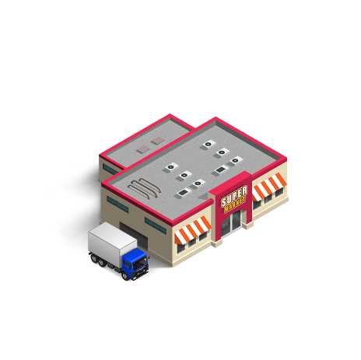The game world is located inside a city. Three different distinct locations inside the game which the player needs to go to them to complete each level.

* + - * 1. The hospital
        2. 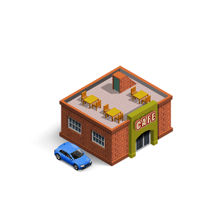The supermarket
        3. The café
    1. *Travel*

The player will move in the game world horizontally and vertically forward or backward in the same scene, the camera will move backward and forward following the player.

* + 1. *Scale*

The game is based on 2D dimensions, the setup is static and the size of the object and screen is fixed. It is easier to control in 2D dimensions. The player scale will be slightly bigger than the real world compared to the city scale and the coronavirus which is the enemy will be bigger than the real world in which humans can not see with their eyes. The scale of this game will highlight the player and the enemy compared to other objects.

* + 1. *Objects*

There are a few objects in this game, the coronavirus, the three main characters of the game, the police, and the medic vehicles on the road. See the “Objects Appendix” for a list of all the objects found in the world.

* 1. **Temporal dimension**

Time in our game is done using real-time of the device, it’s not crucial for the gameplay but it is used to measure how much time the player took to complete the level, the player will receive a report at the end of the level of the time token and a rating will appear to the player.

* 1. **Environmental dimension**

This section discusses the context of the game during level selection and level environment setup

* + 1. *Level selection*

There will be a levels screen in which the player can choose levels, the player must start with the first level which is the easiest level and has one star, the second level is the supermarket which has medium difficulty and has two stars, the last level is the cafe which is the hardest level and has three stars. The levels screen can be seen in the world layout section of this document.

* + 1. *Level environment setup*

Every level will have a different environment as the player will notice the city changes and also there will be a different destination. In addition, the levels will be more difficult as the player advances in the game. The three different destinations according to levels in the game can be seen in the world layout section of this document.

* 1. **Emotional Dimension**

This section covers the mood and feelings the game attempts to inspire within the player and also emotions appear on the character.

* + 1. *Changing mood*

As the player advances in the game, the game will get more difficult for the player and it will make the player feel much more intense to play the level and to reach the destination and achieve winning.

* + 1. *Penalty*

The player will be given a penalty of failure if she did not reach the destination or if she ran out of mask and lives or time. See the defeat screen in the user interface section of this document.

* + 1. *Reward*

The player will be rewarded if she successfully finishes the level and a winning screen will appear with a nice animation and a rating will be given to the player based on the time she took to finish the level and she will be allowed to move to the next level. See the winning screen in the user interface section of this document.

* + 1. *Character Emotions*

Character emotions are not changing during the gameplay for better performance, the following figure shows the the character face reactions during the gameplay, in the figure the normal emotion, when the player fires her weapon which enhances the player experience and engages the player with the changes in the game.

1. **The world layout**
   1. **Overview**

This section provides a look at the world layout in terms of level selection using three different and the layout of each level.

* 1. **Level selection**

This layout is a red background contains corona figures and clouds on top, there are three levels to choose from, but for a new player, they must start with the first level and when they finished the first level, then they can proceed to next level. The next figure shows the level selection screen with the three levels inside and a back button to the main screen. There is another last level called party level.

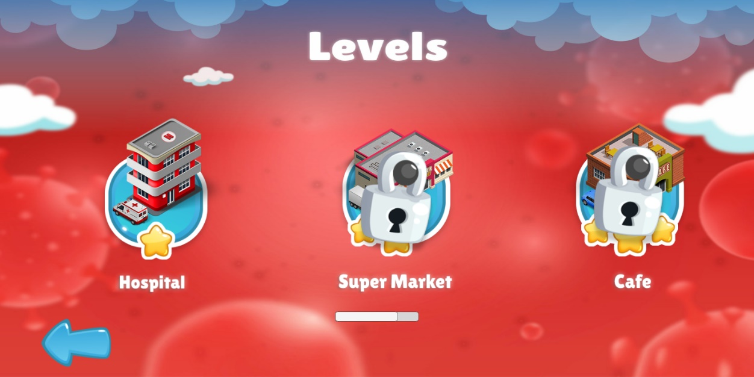

* 1. **Level layout**

Each level is different in its layout in which the city becomes a little different, and the destination will be different. The following figures show different backgrounds and the different destinations used in the game.

The difficulty will increase from the easiest level to the medium and the hardest, the difficulty will be in form of more coronaviruses will attack the player and try to take her down, other objects in the game will be the police car, the player will see it at the police checkpoint in his way to the destination and will see the medic car at the hospital, the two objects are shown in the following figures

The levels of the game are as follows:

* Easy, the hospital has low risk from the coronavirus in the real world, in the hospital, medical officers are always fighting the virus there, so it’s a very safe and low-risk area, and we implement that in our game by making this is the easiest level in the game.
* Medium, the supermarket, it’s riskier than the hospital, people are using masks but the virus can still exist as there is no one fighting it in the supermarket.
* Hard, the café, the risk is very high as people are eating without face masks and some cafes don’t follow SOP correctly.
* Last level, party level, it is used only to raise awareness about how dangerous going to a part in pandemic.

1. **Game characters**
   1. **Overview**

In this section, game characters will be highlighted.

* 1. **Characters**

Our game has three main characters, the main character is the player fighter, the player will play the game with this character and she will fight the coronavirus until she reaches the destination. The second character is the police officer, she will wait at the checkpoint, the third character is the medic, the medic will also be waiting at the every destination of the three destinations. The three characters can be seen from the following figures.

The fighter The medic The police officer

* 1. 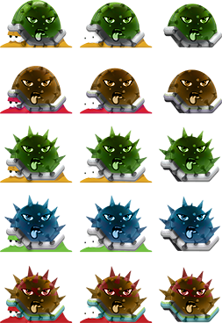**Enemies and Monsters**

As our game's main goal is to raise awareness about the dangerous risks of the coronavirus, our enemy in the game will be a big size cartoon version of the virus. The enemy can be seen from the following figure.

1. **User Interface**
   1. **Overview**

The user interface for this game consist of common graphics, a set of colors is being used inside the game to enrich the user appeal of the game. The player can play the game in landscape mode only and the theme for this game is red and white. The main color of the game is red with code # bb1f1e.

* 1. **Buttons**

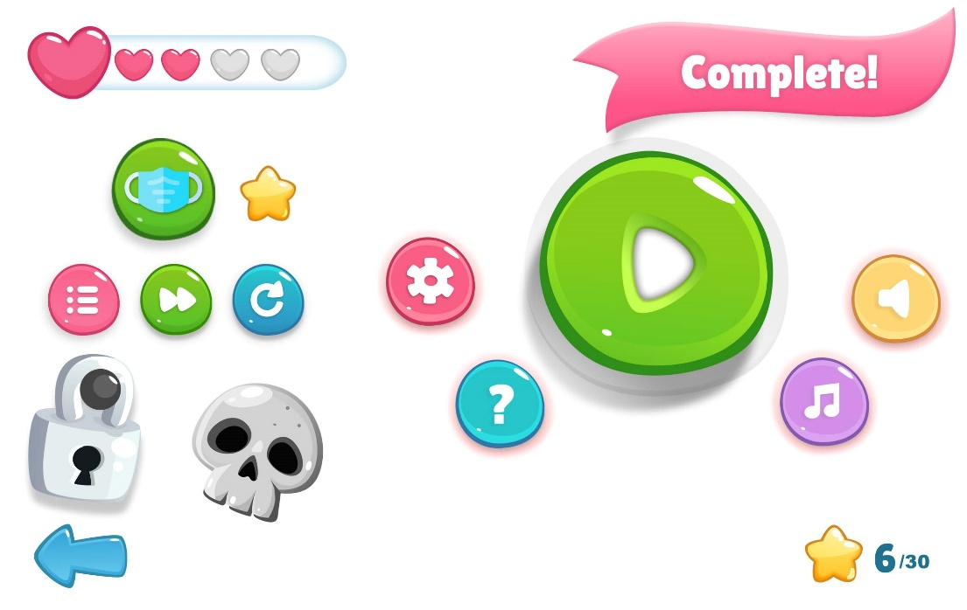In the following figure main buttons inside the game from different screens.

* 1. **Screens**

The following figure the design of the main screens used inside the game, more screens will be added according to the development team.

Home Screen Level Selection Screen

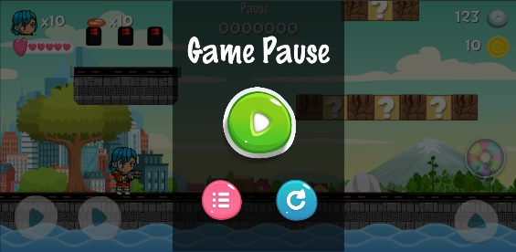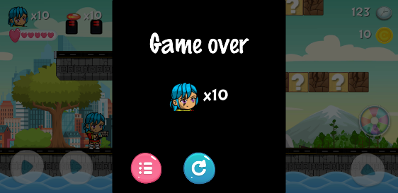

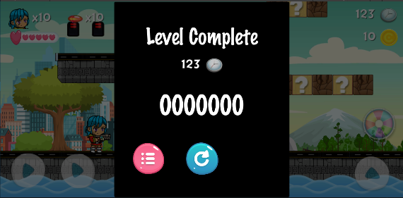

Win, Lose, loading, and finish Screens

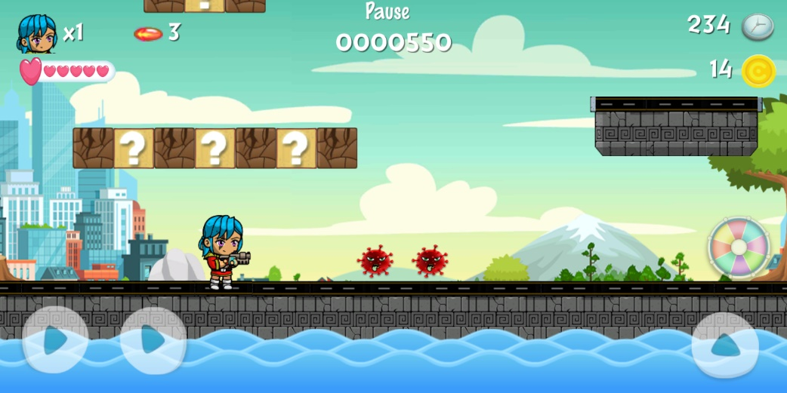

Play mode (interactive) screen

1. **Weapons**
   1. **Overview**

In this section we will mention the weapons used in this game, weapons are mainly used by the player to defeat the coronavirus, but there are also weapons with the medic and the police officer.

* 1. **Main character weapons**

The following figure shows the weapons that our main character will use in the game to defeat the coronavirus enemy.

* 1. **Secondary characters weapons**

The following figure shows the weapons used by the secondary characters which are the medic and the police officer, the medic will use his weapon which is a medical box to give the player a face mask, and a shield to protect from corona, the police officer will have a stick and a shield.

1. **Musical scores and sound effects**
   1. **Overview**

This section contains the main music and sound effects that will be used inside the game to enhance the gameplay experience and make the game alive, new sounds will be added in the future. The background music is from Storyblocks while the sound effects are from Freesound, and Freesfx.

* 1. **Background music**

The game will use “Beast Mode Activated” music by artist “Jonathan Mogavero” as background music.

* 1. **Sound effects**

The game will contain a list of other sound effects, listed in the following list

* Bubble and BubbleLight by “Glaneur de sons”.
* Plop by “pacomav”.
* Magical by “jobro”.
* BubbleButton by “Godowan”.
* Magical02 by “renatalmar”.
* Lose by “zagi2”.
* Win Sound by “mckinneysound”.

1. **Single-player game**
   1. **Overview**

The game is a single-player game based, the player has to travel throughout the city to the destination and going to fight with the corona (enemy) along the way before reach to her destination to win the game.

* 1. **Story**

The coronavirus has invaded the city, only the police and the medical officers are facing the danger and fighting it, a new hero in town is needed to fight the great enemy that all the city is facing and make everything goes back to normal, so all people of the city can restore their normal life back. A new hero is here, she comes with a laser weapon and armed with an extra face mask, we believe that she will beat the enemy and be the city new hero, she will always be remembered for her heroic actions.

* 1. **Hours of Gameplay**

The game experience is supposed to last for 15 minutes per each level if the player is a fast player and supposed to last 45 minutes per each level for the slower player.

* 1. **Victory Conditions**

The single-player who plays this game will win if completed all three levels and pass the bonus level.

1. **Character rendering**
   1. **Overview**

In this section, we will explain how the game is designed and how it is rendered inside the 2D game engine.

* 1. **Character design**

Our characters are designed as separate images in which the body parts, clothes, and weapons of the characters are separately designed and then put together to form the characters, we used a tool to design our characters called Character Editor by “Hippo”.

* 1. **Rendering**

The characters will be rendered inside the game engine as sprite sheet can be controlled via script and interacted with, we also using 2D colliders to specify the surfaces that the character can stand on and move. The following figures show screenshots from the game engine unity inside a test room created for testing.

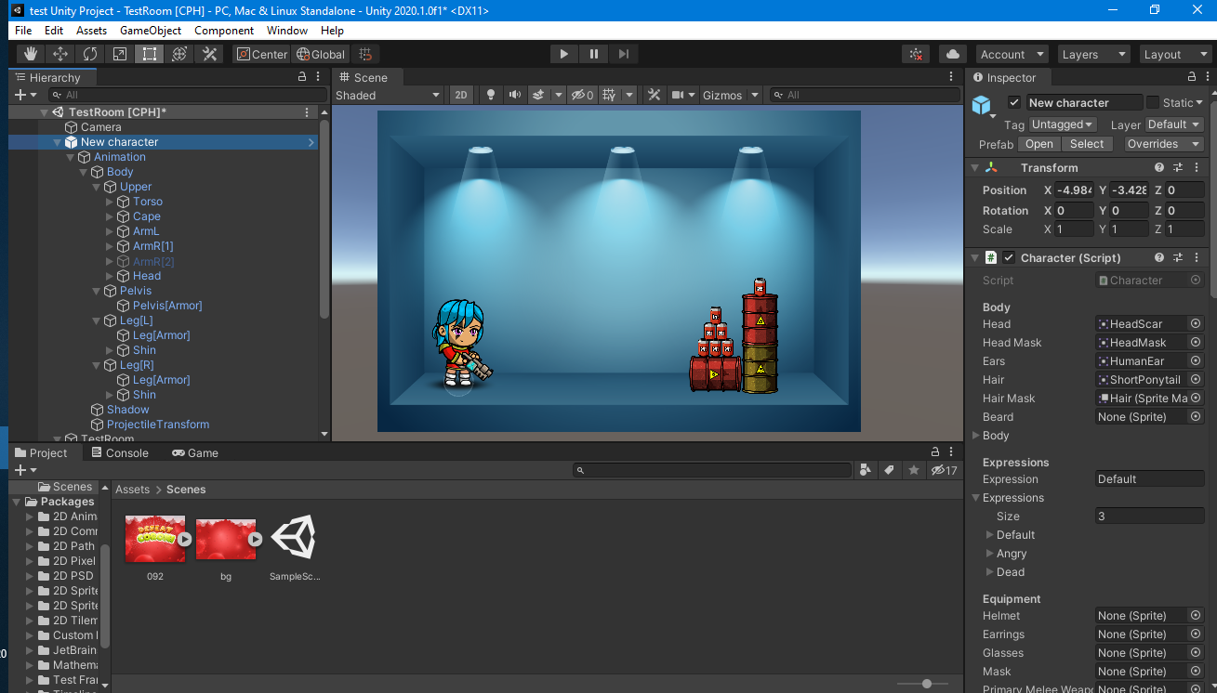

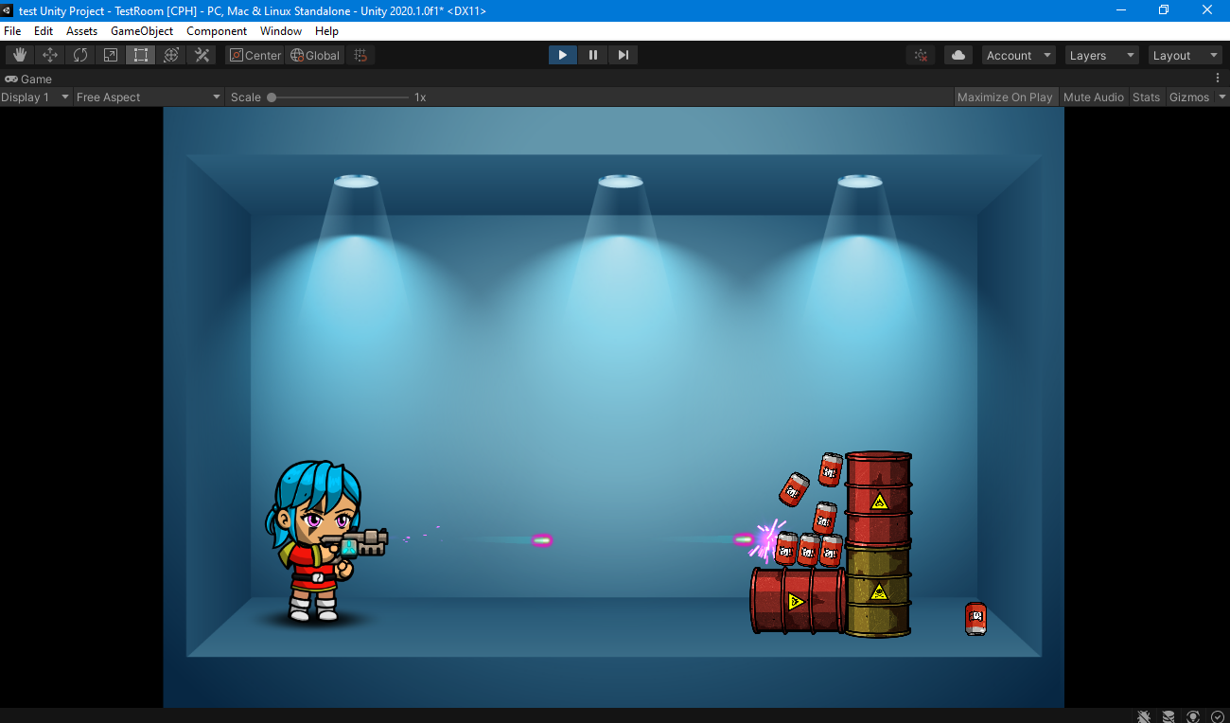

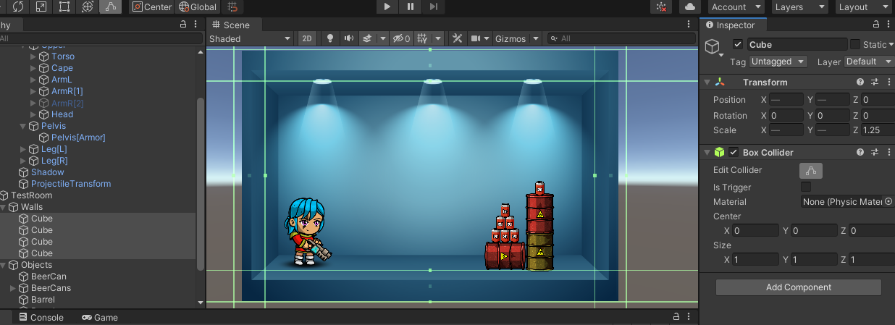

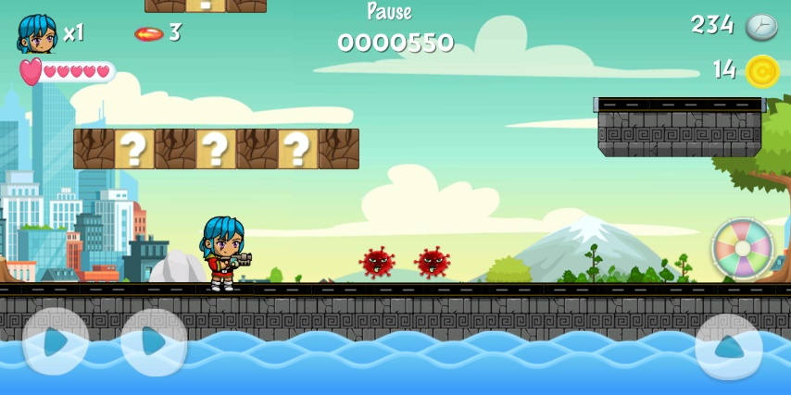

1. **Miscellaneous**
   1. **Credits**

|  |  |
| --- | --- |
| **Tasks** | **Participants** |
| **Development Phase** |  |
| Design, levels, character, and UI | All Team Members [Yana, Ziera, Mahmoud, Afiq, Theva] |
| Story and text creating | Theva, Mahmoud |
| Developing and coding | All Team Members [Yana, Ziera, Mahmoud, Afiq, Theva] |
| Audio, music, and sound design | Ziera, Mahmoud |
| **Testing and deployment phase** |  |
| Testing and deployment | Afiq, Mahmoud |

* 1. **Bonus Materials**

After the player went to the hospital, the supermarket, the café which are considered essential places to go. A bonus level will at the end of the three levels, in this bonus level, only a question will be asked to the player in which she will go to a party organized by her friend, if she accepts the invitation, she will lose the game, this level rises the awareness of the risk taken by going to non-essential places like a party where the risk of infection is very high during the times of a pandemic like a coronavirus.

1. **Appendices**
   1. **Levels appendix**

|  |  |  |  |
| --- | --- | --- | --- |
| **Level** | **Name** | **Difficulty** | **Prerequisite** |
| 1 | Hospital | Easy | None |
| 2 | Supermarket | Medium | Level 1 |
| 3 | Café | Hard | Level 2 |
| 4 bonus | Party | Very easy | Level 3 |

* 1. **Objects Appendix**

|  |  |  |
| --- | --- | --- |
| # | **Name** | **Location** |
| 1 | Police car | At the checkpoint, each level |
| 2 | Medic car | At the hospital, level 1 |
| 3 | Cargo car | At the supermarket, level 2 |
| 4 | Civilian car | At the café, level 3 |
| 5 | Coroni, the enemy | At each level |
| 6 | Face mask | At the checkpoint, each level |
| 7 | The city background | At each level |
| 8 | The road | At each level |
| 9 | coins | After every coroni death on the road |
| 10 | Face masks | Random locations |
| 11 | ammo | Random locations |

* 1. **Characters and weapons appendix**

|  |  |  |  |
| --- | --- | --- | --- |
| # | **Character** | **Weapon** | **Weapon purpose** |
| 1 | The main character, the fighter | Laser gun | Kill coroni |
| 2 | Police officer | Stick and shield | Kill coroni at the checkpoint and defend against coroni attacks |
| 3 | Medic officer | Medical box and shield | Provide mask for the fighter and defend against coroni attacks |
| 4 | Coroni, the enemy | bullets | Kill the fighter |
| 5 | Coroni snail | Mini coroni | Kill the fighter |
| 6 | Coroni spike | spikes | Kill the fighter |
| 7 | bat | fly | Kill the fighter |

* 1. **Rating Appendix**

|  |  |  |
| --- | --- | --- |
| # | Rating | duration |
| 1 | One star | Finish level in 15 minutes |
| 2 | Two stars | Finish level in 30 minutes |
| 3 | Three stars | Finish level in 45 minutes |

* 1. **Tools Appendix**
  + Adobe Photoshop
  + Adobe illustrator
  + Unity 2D version 2020.1.0f1 pro
  1. **Sound Appendix**

|  |  |  |
| --- | --- | --- |
| # | File name | File name |
| 1 | background_music | JumpOnHead |
| 2 | Battle theme | KillMonster |
| 3 | Button, ButtonLight | Land (mp3cut.net)_2 |
| 4 | eat | Level Up |
| 5 | hiting_body | pop |
| 6 | Jump2 | SecondsRemaining |
| 7 | countingPoint | ShootHit (mp3cut.net) |
| 8 | DestroyBrickBlock | Spring |
| 9 | DestroyItemBlock | thrown miss |
| 10 | Click, collect | thrown |
| 11 | thrown | WallSlide |
| 12 | water | Wa-wa-wa-sound |
| 13 | Winning-sound-effect |  |

* 1. **Team roles**

1. **References**

* Vectors and city backgrounds used in designing the city are on “freepik.com”.
* Characters design with the help of “character editor tool” by “Hippo” on unity asset store “assetstore.unity.com”.
* User interface design with the help of “Cartoon GUI Pack” by “ricimi” on unity asset store “assetstore.unity.com”.
* Background music by “Jonathan Mogavero” on “storyblocks.com”.
* Bubble and BubbleLight by “Glaneur de sons” on “freesound.org”.
* Plop by “pacomav” on freesound.org”.
* Magical by “jobro” on “freesound.org”.
* BubbleButton by “Godowan” on “freesound.org”.
* Magical02 by “renatalmar” on “freesound.org”.
* Lose by “zagi2” on “freesound.org”.
* Win Sound by “mckinneysound” on “freesfx.co.uk”.

Thank you…